1. DESIGN AN ARDUINO PROGRAM TO DISPLAY BLINKING LED

CODE:

const int LED = 13;  
void setup()  
{  
pinMode(LED, OUTPUT);  
}  
void loop()  
{  
digitalWrite(LED, HIGH);  
delay(1000); // Wait for 1000 millisecond(s)  
digitalWrite(LED, LOW);  
delay(1000); // Wait for 1000 millisecond(s)  
}

Output

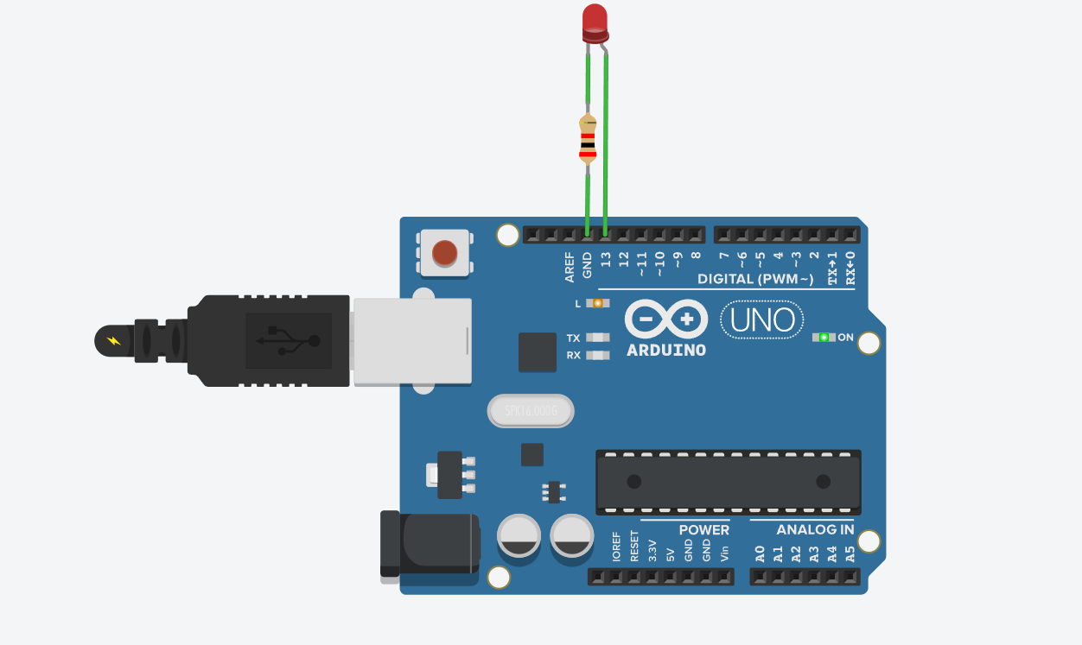

Conclusion: The experiment to design an arduino program to simulate Blinking led light was completed successfully.

1. DESIGN AN ARDUINO PROGRAM TO SIMULATE THE TRAFFIC SIGNALS

CODE:  
const int RED = 13;  
const int YELLOW = 12;  
const int GREEN = 8;  
void setup()  
{  
pinMode(RED, OUTPUT);  
pinMode(YELLOW, OUTPUT);  
pinMode(GREEN, OUTPUT);  
}  
void loop()  
{  
digitalWrite(RED, HIGH);  
delay(1000);   
digitalWrite(RED, LOW);  
digitalWrite(YELLOW, HIGH);  
delay(1000);   
digitalWrite(YELLOW, LOW);  
digitalWrite(GREEN, HIGH);  
delay(1000);   
digitalWrite(GREEN, LOW);  
}

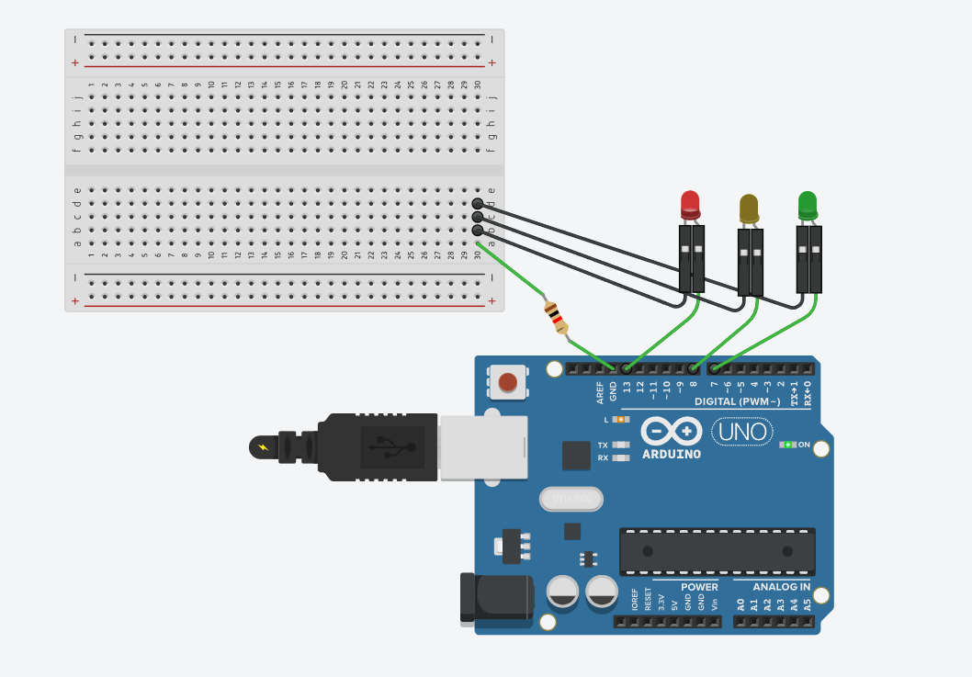

Conclusion: The experiment to design an arduino program to simulate the traffic signals was completed successfully.